1. If we want to output the current value of allowNewServer, we can use String Interpolation, to simply output a new server. And the Boolean value gets cast to a string

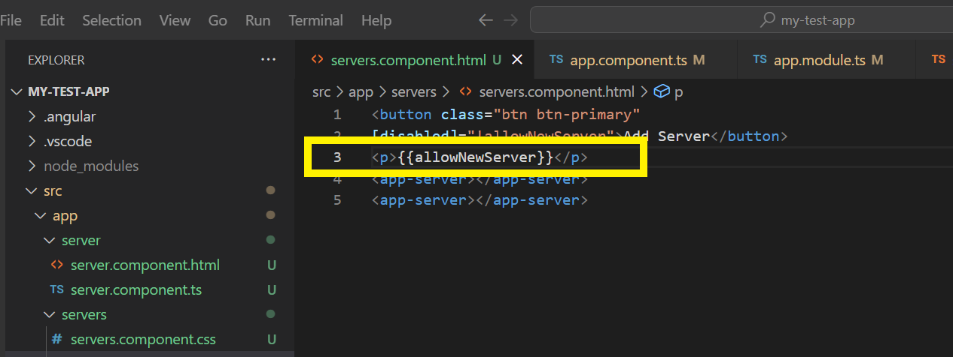

1. We can observe the same in browser.

1. **Using innerText for Property Binding:**

The same scenario is one of the cases, where we can easily use property binding instead of string interpolation. We can simply bind to a property of this element, using the innerText property and set this ‘equal’ to allow a new server. And by doing that we get the same behavior now, which we earlier achieved using String interpolation

1. **When to use String Interpolation and Property Binding?**

* If you want To output something in your template, print some text to it – Use String interpolation
* If you want to change some property of a html element or a directive or a component – Use property binding

1. **Important Note:**

* Don’t mix property binding and string interpolation
* <p [innerText]="allowNewServer"></p>
* This syntax is not just used by html, instead it is a syntax recognized by Angular
* Between quotation we should always have typescript code only and not have the string interpolation code i.e curly braces
* String interpolation works only in normal template.